


ECOMMERCE WEBSITE
A Mini Project Submitted in Partial Fulfilment Of The Requirements for the degree of

Bachelor of Technology
In
Computer Science & Engineering (Artificial Intelligence & Machine Learning)

- Riya Singh RollNo:2201331530161
- Shraddha RollNo:2201331530177

Under the Supervision of:
Ms. Aarushi Thusu
(Assistant Professor, Department of CSE (AIML))
Ms. Neelam
(Assistant Professor, Department of CSE (AIML))

DEPARTMENT OF COMPUTER SCIENCE AND ENGINEERING
(Artificial Intelligence & Machine Learning)
NOIDA INSTITUTE OF ENGG. & TECHNOLOGY, GREATER NOIDA, GAUTAM BUDDH NAGAR
(AN AUTONOMOUS INSTITUTE)

(Approved by AICTE and affiliated to Dr. A.P.J. Abdul Kalam Technical University, Uttar Pradesh, Lucknow)

Certificate

I hereby certify that the work which is being submitted in the Project Report entitled “ECommerce Website” in partial fulfillment of the requirements for the award of the Bachelor of Technology in Computer Science and Engineering Artificial Intelligence & Machine Learning and submitted to the Department of Computer Science & Engineering Artificial Intelligence & Machine Learning, Noida Institute of Engineering & Technology, Greater Noida is an authentic record of my Internship carried out during Third semester under the supervision of Ms. Purnima Pal(Assistant Professor), Department of Computer Science and Engineering Artificial Intelligence, Noida Institute of Engineering & Technology, Greater Noida. The matter embodied in this project Report is original and has not been submitted for any other degree or diploma award.

Signature of Candidate
Riya Singh 2201331530161
Shraddha 2201331530177

This is to certify the above statement made by the candidate is correct and true to the best of my knowledge.

Signature of Supervisor Signature of HOD
Ms. Aarushi Thusu Dr. Arjun Raj
(Assistant Professor) (Associate professor)
Ms. Neelam
(Assistant Professor)

DECLARATION

I hereby declare that this submission is my own project and that, to the best of my own knowledge and belief, it contains no material previously published by another person nor material which, to a substantial extent, has been accepted for the award of any other degree or diploma of the university or other institute of higher learning except where due acknowledgment has been made in the text.

Signature of Candidate
Riya Singh 2201331530161
Shraddha
2201331530177

Acknowledgement

Successfully completing any task gives us satisfaction and internal strength for future problems, but the person alone has never existed. A few people truly accompany him. They used to give the person support and suggestions to complete the work successfully. So, I feel pleasure thanking all such great people who motivated me and provided me with kind support at all stages of my Internship Project work.
Firstly, I would like to honor my institute, “Noida Institute of Engineering & Technology, Greater Noida”. Here, I have been provided with a workplace and infrastructure to learn recent technologies and conceptual background to strengthen my programming and professional skills.
I am very much grateful to Ms. Aarushi Thusu, Assistant Professor (Computer Science and Engineering Artificial Intelligence & Machine Learning), and Ms. Neelam, Assistant Professor (Computer Science and Engineering Artificial Intelligence & Machine Learning), and Dr. Arjun Raj(Professor & Head, Computer Science and Engineering Artificial Intelligence & Machine Learning), Noida Institute of Engineering & Technology, Greater Noida, for his helpful attitude and encouragement in making my project.
Furthermore, I am thankful to all faculty members for motivating me and the Staff of Computer Labs in the department for providing excellent valuable facilities, issuing me a computer system of good configuration, and providing regular maintenance.
I thank all my batch mates for their love, encouragement, and constant support.
Last but not least, I would like to thank my parents for supporting me to complete my project report in all ways.

Signature of Candidate
Riya Singh 2201331530161
Shraddha
2201331530177

TABLE OF CONTENTS:

S. No. | TITLE | Pg No.
1. | Abstract | 6
2. | Introduction | 7
3. | Project Modules | 8
4. | Technology Background | 9
5. | Snapshots of Project | 12
6. | Objective | 13
7. | Citations | 14

Abstract

The ECommerce project is a full-stack e-commerce web application designed to offer a seamless and responsive online shopping experience. It integrates modern front-end technologies with a robust back-end architecture to handle essential e-commerce functions such as user authentication, product browsing, cart management, order placement, and secure payments. Admin features include product management and order tracking. The application ensures cross-device compatibility and addresses key challenges like inventory updates and user experience optimization. This project demonstrates the practical application of full-stack project developed.

INTRODUCTION

The E-Commerce project is a comprehensive full-stack e-commerce web application developed to streamline the online shopping experience for both users and administrators. With the rapid growth of digital retail, this project aims to provide a scalable, secure, and user-friendly platform for browsing, purchasing, and managing products online. Built using modern web technologies, the application covers essential e-commerce functionalities such as user registration, product listings, cart operations, order management, and secure payments. It also offers admin-level controls for efficient store management. This project not only demonstrates practical implementation of full-stack development concepts but also addresses real-world challenges in online commerce.

Project Modules

- Authentication Module
This module manages user login, signup, and session handling to secure access across the application.
  - Location: context/ (e.g., AuthContext.js)
  - Components: Login, Signup, ProtectedRoute
- Product Listing & Search Module
Displays all available grocery items with support for filtering and searching by category, name, or price.
  - Location: pages/ or components
  - Components: Product Card, Search Bar, Category Filter
- Cart and Checkout Module
Enables users to add or remove products, view cart contents, and proceed with secure order placement.
  - Components: Cart, Cart Item, Checkout Form
- Order Management Module
Allows users to track current orders and view their complete order history.
  - Pages: My Orders, Order Details
- Admin Module (Optional)
Provides administrative capabilities to manage products, categories, users, and order logistics.
  - Pages: Admin Dashboard, Add Product, Manage Orders
- Asset Management
Static assets like product images, banners, and branding visuals are organized in a central directory.
  - Directory: assests/
- UI & Styling
Global styles and layout components maintain design consistency across the site.
  - Global Styles: index.css
  - Shared Components: Header, Footer, Navbar
- App Entry Point
Initializes and renders the application using React's core setup.
  - main.jsx: Mounts the app using ReactDOM.render()
  - App.jsx: Contains the main component tree and route configurations

Technology Background( E-Commerce Website)

Programming Languages

  - JavaScript & JSX: Used with React for building interactive UI.
  - Node.js : For backend services and APIs.

Frontend Framework

  - React: Component-based UI development.
  - React Router: Handles navigation between pages like Home, Cart, and Orders.

Styling and UI

  - CSS : For responsive design.

Development Tools
  - VS Code: Code editor.
  - Git + GitHub: Version control.

SNAPSHOTS OF PROJECT

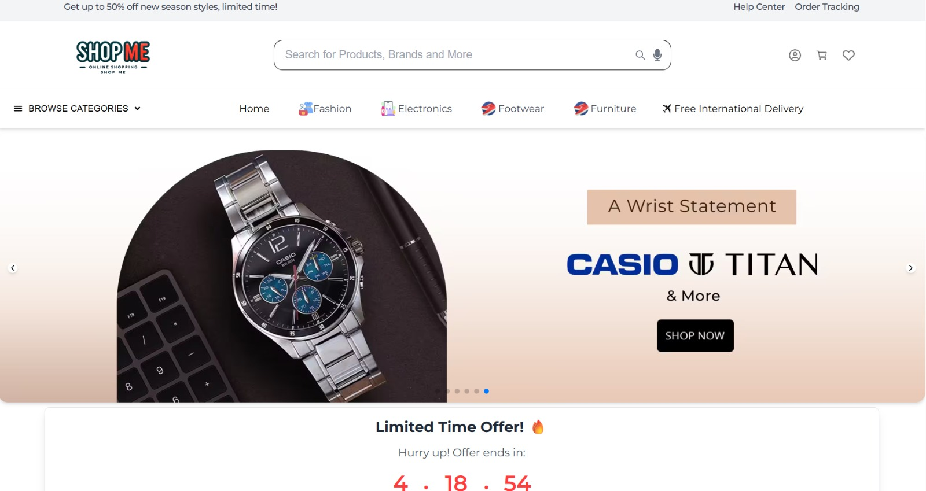

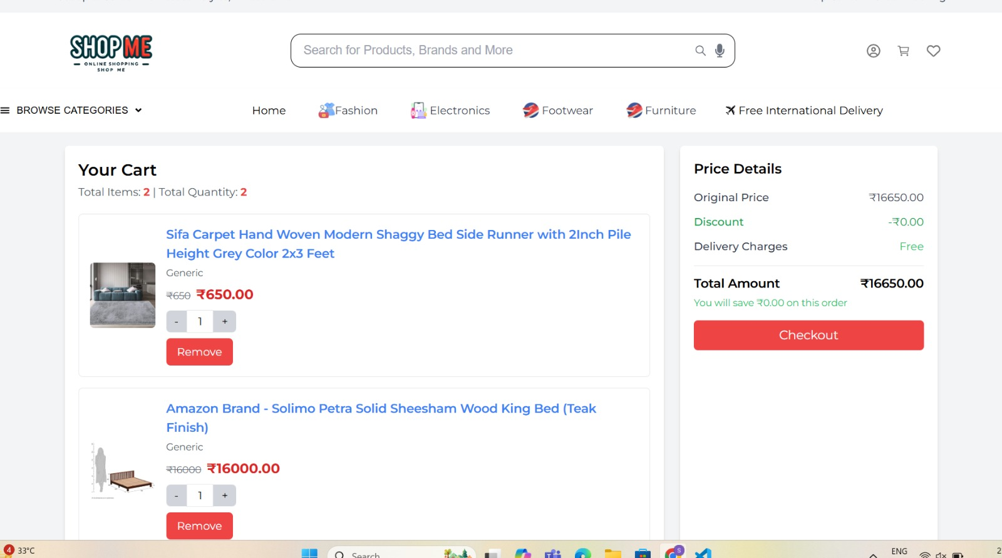
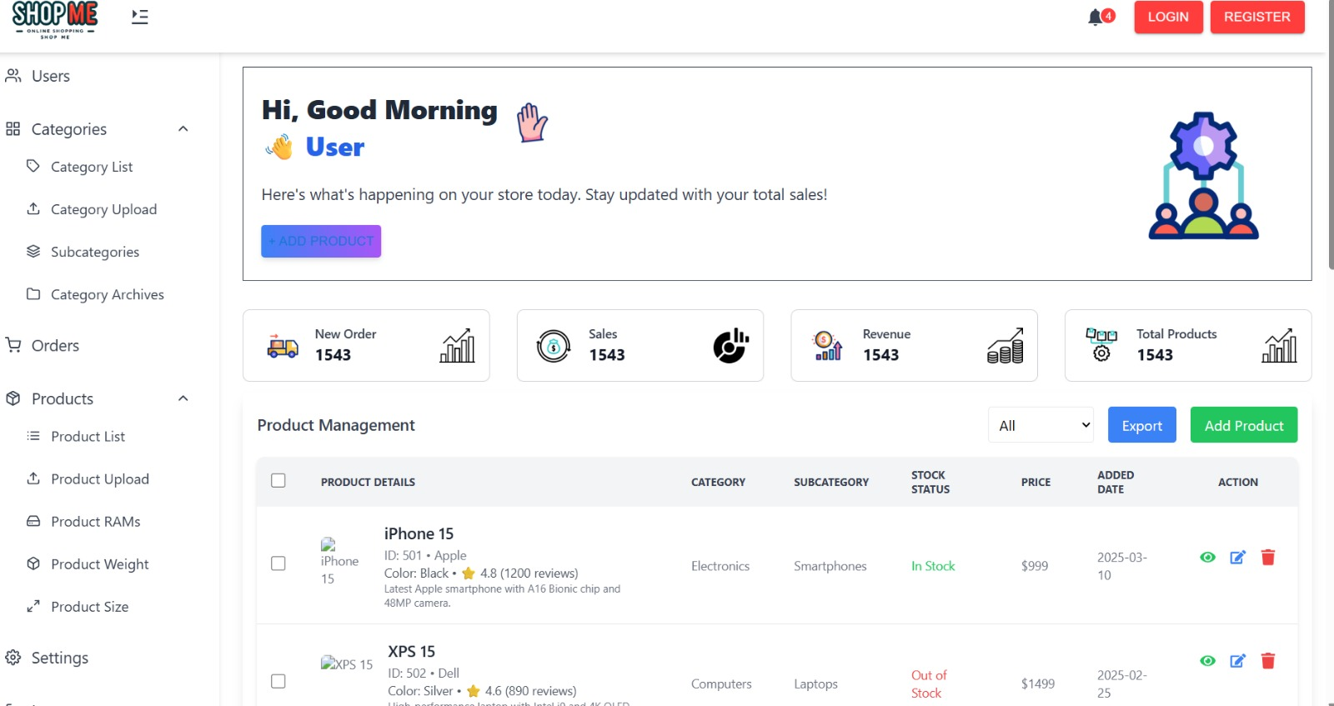

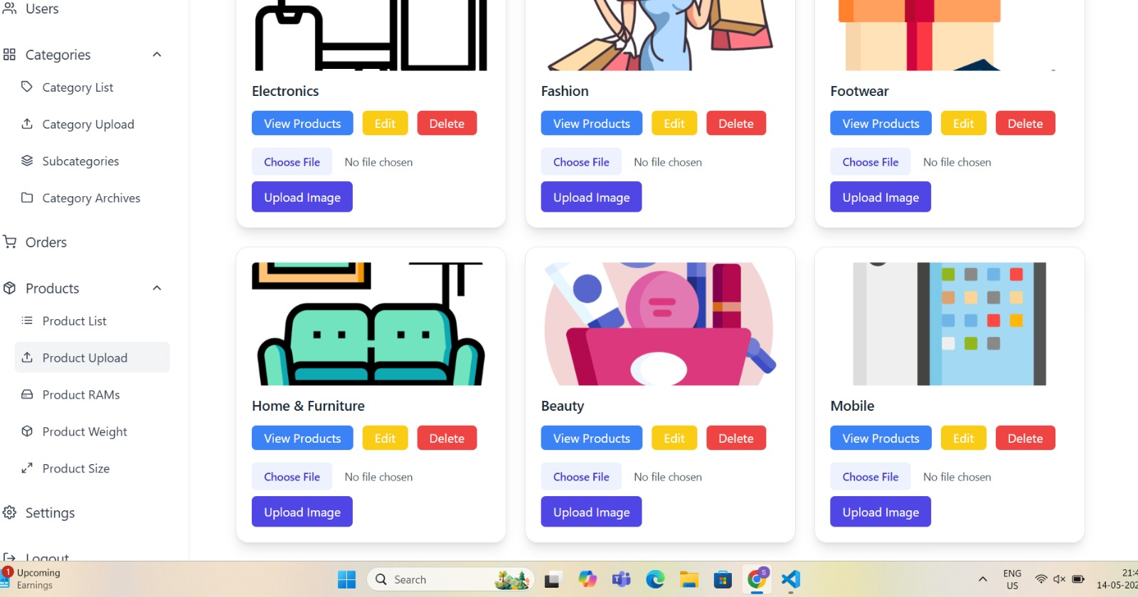
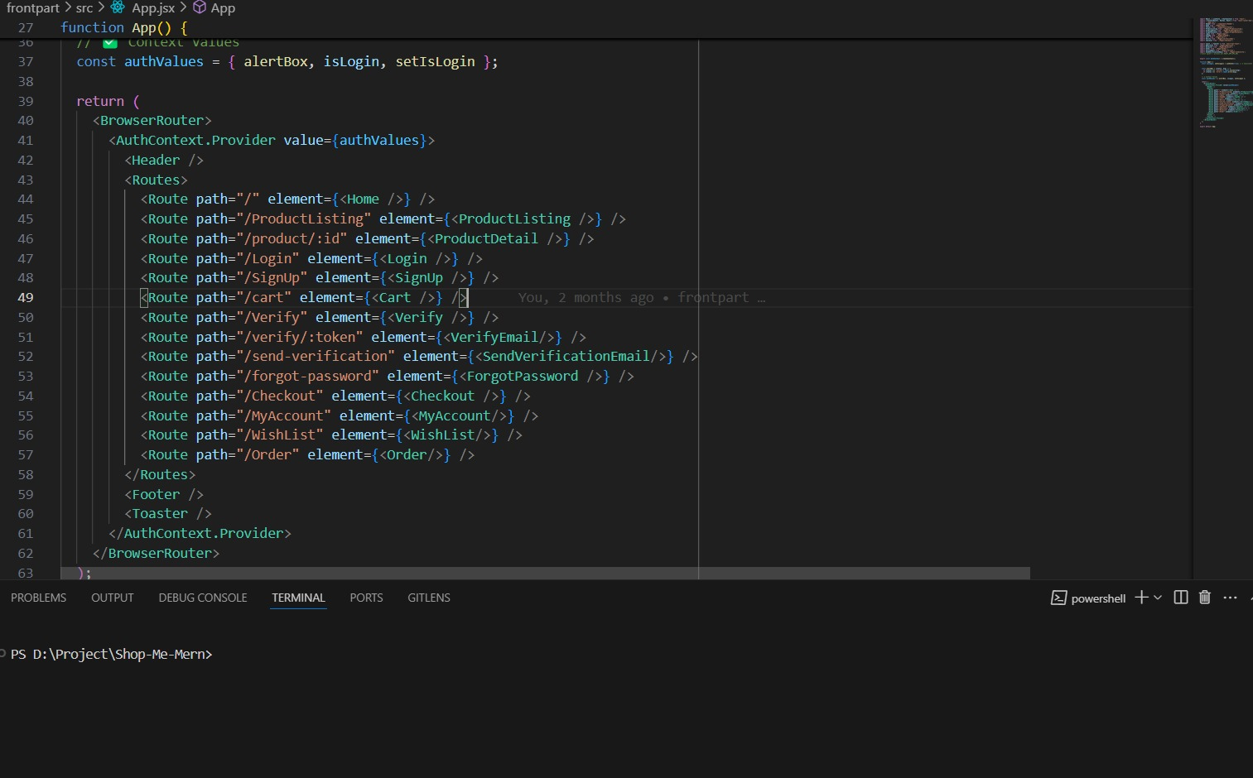
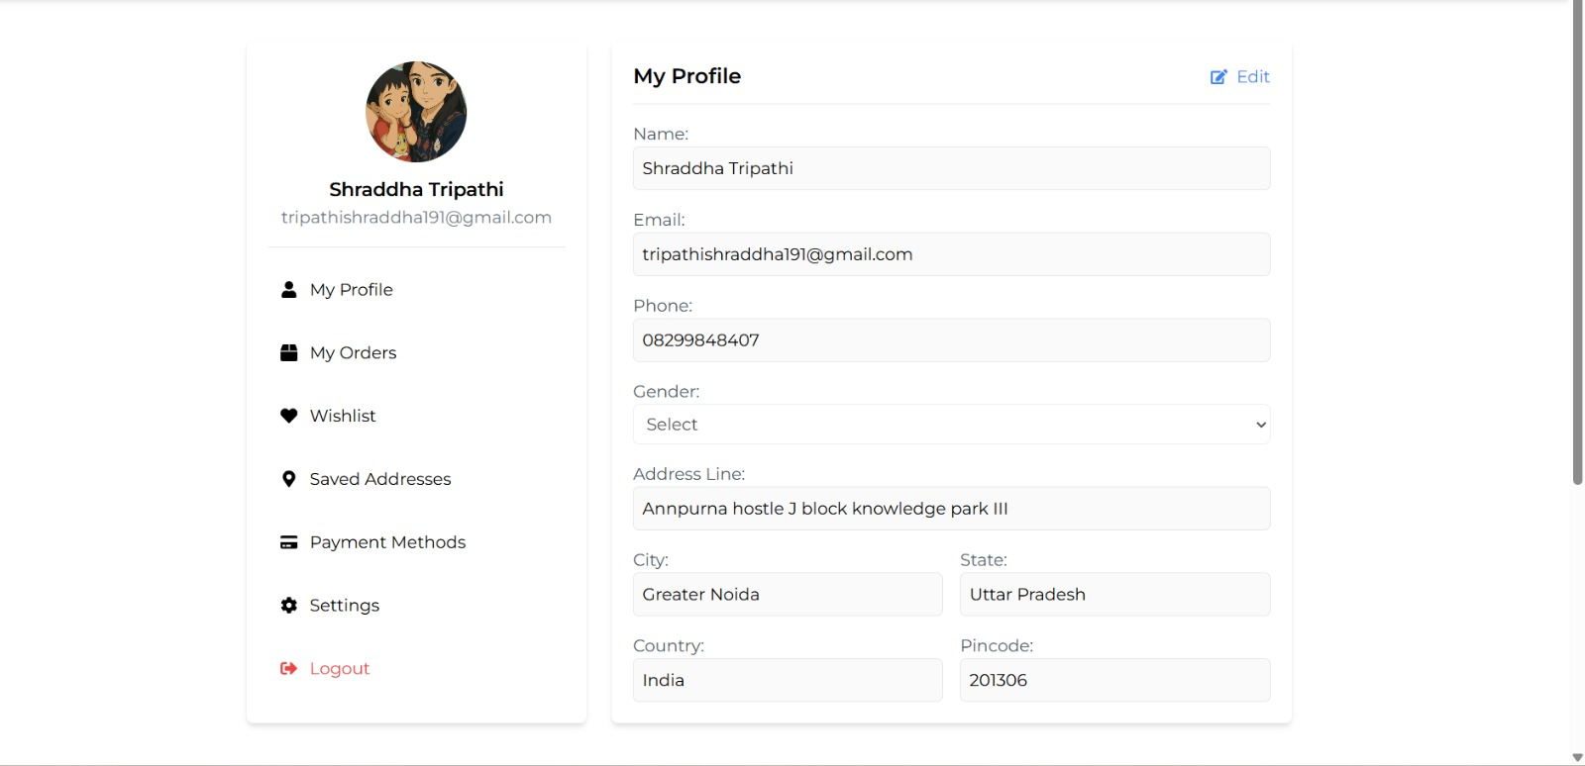

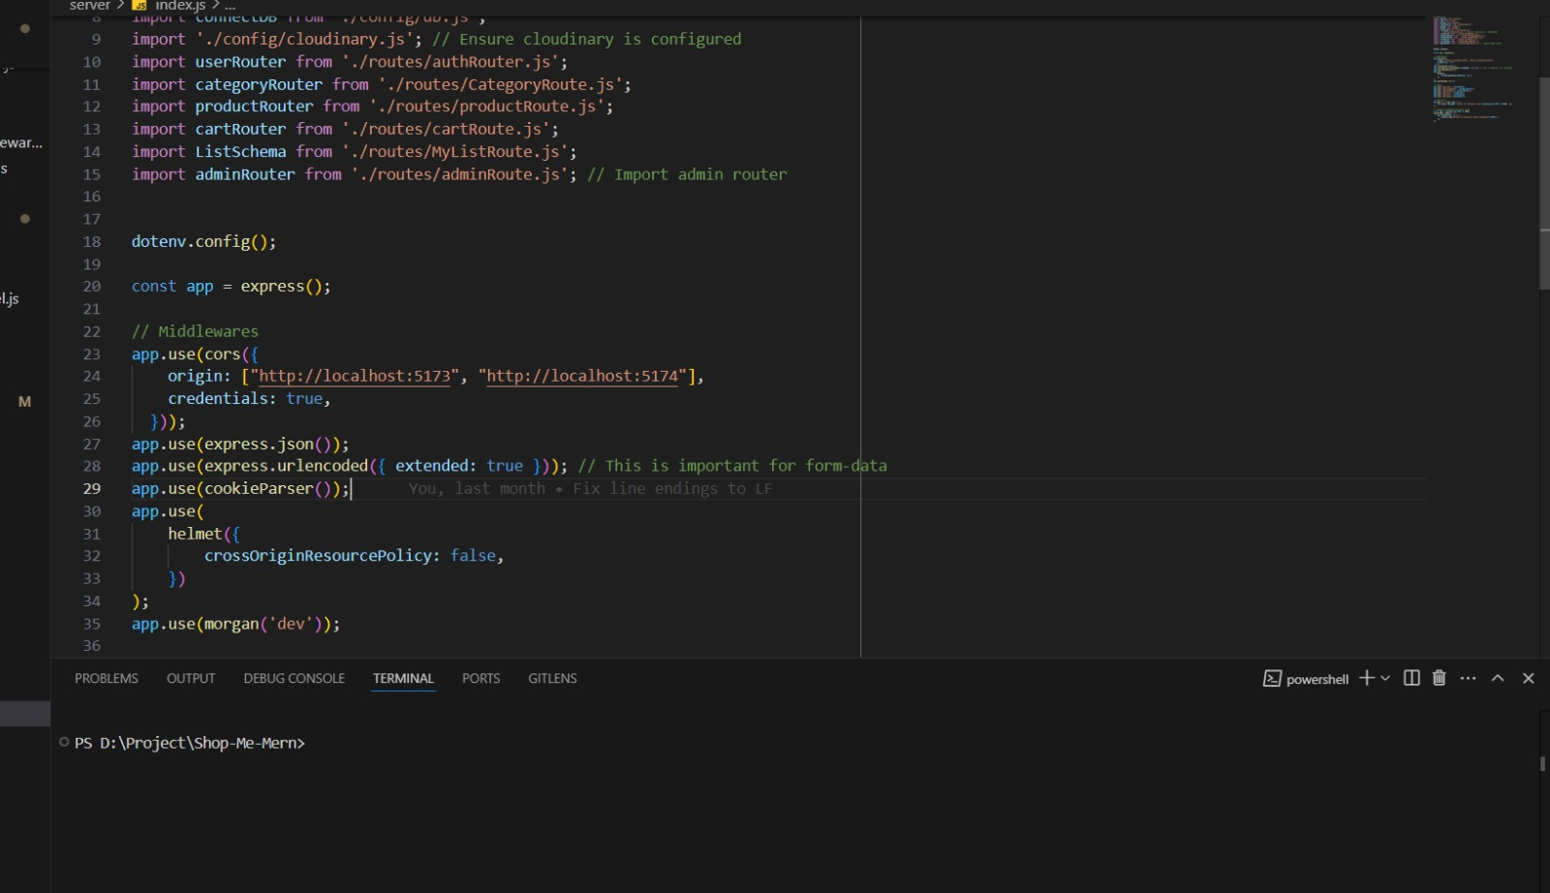

Objective

- Convenient Ecommerce Shopping: Enable users to browse and purchase products from the comfort of their homes through a user-friendly web platform.
- Real-Time Product Availability: Provide up-to-date listings of available items, ensuring users can view and order products currently in stock.
- Efficient Order Management: Allow customers to seamlessly add items to the cart, place orders, and track deliveries in real time.
- Secure User Authentication: Ensure safe and personalized user experiences through secure login, registration, and account management features.
- Payment Integration: Offer multiple secure payment options including digital wallets, cards, or cash on delivery.
- Delivery Optimization: Facilitate timely and accurate deliveries through an integrated logistics module or third-party API.
- Promotions & Personalization: Deliver personalized recommendations, promotions, and offers based on user behavior and purchase history.

Citations

Websites

  - React Documentation: https://reactjs.org/
  - MDN Web Docs (JavaScript): https://developer.mozilla.org/en-US/docs/Web/JavaScript
  - GitHub: https://github.com/
  - React Router: https://reactrouter.com/
  - NPM (Packages & Libraries): https://www.npmjs.com/

